embedUR Systems
Campus Training Program – 2026
LINUX TRAINING – ASSESSMENT 4
Name : Muhesh M
College :Thiagarajar College of Engineering, Madurai.

For the attached file, write a bash script which should take the file as input and have to go through it line by line and need to generate an output file (say output.txt) with listings of following parameters fetched from the input file.
Params expected to be fetched from input.txt file:

"frame.time", "wlan.fc.type", "wlan.fc.subtype"
Sample output expected in output.txt:
"frame.time": "Nov 14, 2024 11:44:48.219200000 India Standard Time",
"wlgn.fc.type": "1",
"wlan.fc.subtype": "9"
"frame time": "Nov 14, 2024 11:44:48.219208000 India Standard Time",
"wlan.fc.type": "0",
"wlan.fc.subtype": "1",
and so on.

BASH SCRIPT parameters.sh

#!/bin/bash

if [ $# -ne 1 ]; then
echo "Usage: $0 <input_file>"
exit 1
fi

input="$1"
> output.txt

awk '
/"frame.time"/ {
frame_time = $0
}
/"wlan.fc.type"/ {
wlan_fc_type = $0
}
/"wlan.fc.subtype"/ {
wlan_fc_subtype = $0
}

frame_time && wlan_fc_type && wlan_fc_subtype {
gsub(/ /, "", frame_time)
gsub(/ /, "", wlan_fc_type)
gsub(/ /, "", wlan_fc_subtype)

print frame_time >> "output.txt"
print wlan_fc_type >> "output.txt"
print wlan_fc_subtype >> "output.txt"
print "" >> "output.txt"

frame_time=""
wlan_fc_type=""
wlan_fc_subtype=""
}
' "$input"

echo "Extraction complete. Output saved to output.txt"

Terminal Commands:

- touch parameters.sh
- chmod +x parameters.sh
- gedit parameters.sh
- ./parameters.sh “input.txt”
- gedit output.txt

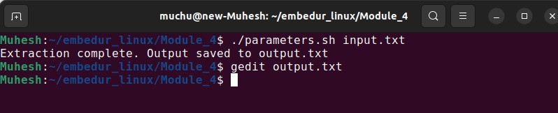

Sample Output output.txt
